Dataset Source and Processing

Original Data Source
Dataset: Protein-Protein Docking Benchmark 5.5
Citation: Vreven, T., Moal, I.H., Vangone, A., Pierce, B.G., Kastritis, P.L., Torchala, M., Chaleil, R., Jimenez-Garcia, B., Bates, P.A., Fernandez-Recio, J., Bonvin, A.M.J.J., and Weng, Z. (2015). "Updates to the integrated protein-protein interaction benchmarks: Docking benchmark version 5 and affinity benchmark version 2." Journal of Molecular Biology, 427(16), 3031-3041.
Access: https://zlab.wenglab.org/benchmark/

Original Data Format
The original dataset is a table (Table_BM5.5.xlsx) with 257 protein-protein complexes containing:
- Complex ID (bound structure identifier)
- PDB ID 1 (unbound protein 1)
- PDB ID 2 (unbound protein 2)
- Protein names and classification (antibody-antigen, etc.)
- Interface metrics (RMSD, buried surface area)

How I Adapted It
Extracted sequence data and interface residue information for our capstone project:
- Downloaded 3D protein structures from RCSB PDB using the PDB IDs from the benchmark table
- Extracted amino acid sequences from the 3D structures using BioPython
- Computed interface residues by identifying which amino acids from Protein A are within 5 Ångströms of Protein B in the bound complex
- Created binary labels (0 = not at interface, 1 = at interface) for each residue

Example: Complex 1AHW

Step | Input | Output
Parse Benchmark | Table row: 1AHW_AB:C | PDB IDs: 1FGN, 1TFH
Download | PDB IDs | 3D structure files (~100 KB each)
Extract Sequences | 3D Coordinates | Protein A: 214 residues; Protein B: 200 residues
Compute Interface | Bound structure + distance threshold | 10 interface residues in A; 9 in B
Create Labels | Interface Positions | [1,0,0,0,0,1,0,0,1,1,0,...]
Save | Generated Data | CSV row with sequences + labels

First 10 protein pairs from the benchmark:
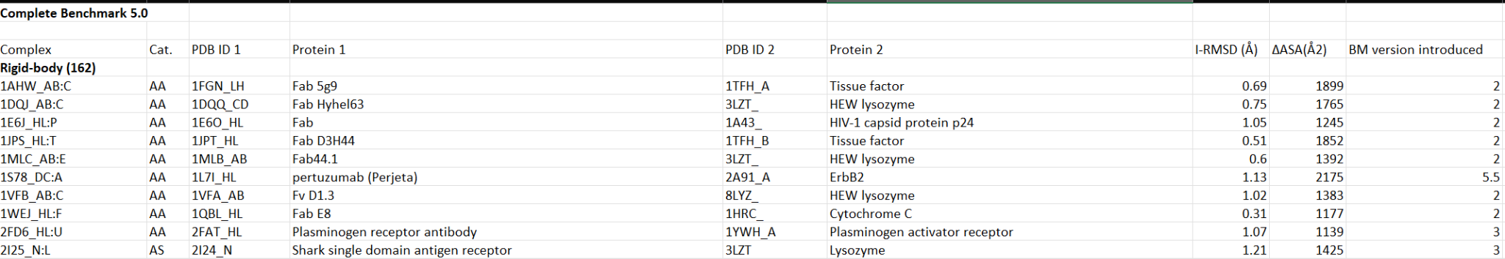
First 10 protein pairs after my transformation:
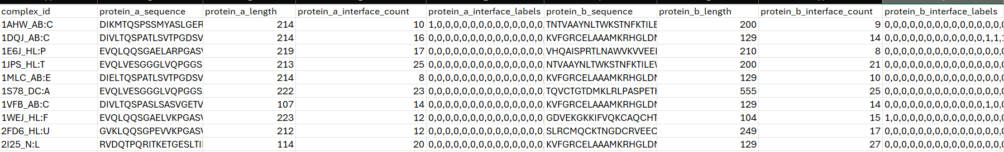

* See ProteinPairDataExtraction.py in the shared drive for the data extraction code.

